

| **Title:** Implementation of private Ethereum Blockchain environment using Geth. |
| --- |

**Objective:** To create your own private Blockchain using Geth

**Expected Outcome of Experiment:**

| **CO** | **Outcome** |
| --- | --- |
| **CO3** | Apply the algorithm and techniques used in Blockchain |
| **CO4** | Grasp the in-depth understanding of Blockchain, Smart Contracts & how it works |

**Books/ Journals/ Websites referred:**

1. **https://geth.ethereum.org/**
2. **https://ethereum.org/**

**Ethereum**

Ethereum is an open-source, public, blockchain-based distributed computing platform and operating system featuring smart contract functionality. “Ether” is the crypto-fuel of the Ethereum network which is used to do transactions. The most sophisticated feature of Ethereum is Smart Contract which is a program that facilitates the exchange of money, content, property, shares or anything of value. The smart contract becomes a self-operating computer program that automatically executes when specific conditions are met. They run exactly as programmed without any possibility of downtime, censorship, fraud or third-party interference.

Ethereum blockchain network is simply a set of nodes connected to every other node to create a network. Each node runs a copy of the entire blockchain and competes to validate and create next block. Whenever a new block is added, the blockchain updates and is propagated to the entire network. Therefore, to become a node in the Ethereum network, your computer will have to download and update a copy of the entire blockchain.

You can build a “private” Ethereum network rather than the public network which can be used to make transactions and build smart contracts without needing real Ether. A private network is the best way to learn the concepts of blockchain without the need for real currency.

**Geth:**

Geth is an Ethereum client written in Go. This means running Geth turns a computer into an Ethereum node. Ethereum is a peer-to-peer network where information is shared directly between nodes rather than being managed by a central server. Nodes compete to generate new blocks of transactions to send to its peers because they are rewarded for doing so in Ethereum’s native token, ether (ETH).

On receiving a new block, each node checks that it is valid and adds it to their database. The sequence of discrete blocks is called a “blockchain”. The information provided in each block is used by Geth to update its “state” - the ether balance of each account on Ethereum.

There are two types of account: externally-owned accounts (EOAs) and contract accounts. Contract accounts execute contract code when they receive transactions. EOAs are accounts that users manage locally in order to sign and submit transactions. Each EOA is a public-private key pair, where the public key is used to derive a unique address for the user and the private key is used to protect the account and securely sign messages.

Therefore, in order to use Ethereum, it is first necessary to generate an EOA (hereafter, “account”). This tutorial will guide the user through creating an account, funding it with ether and sending some to another address.

**Implementation Details:**

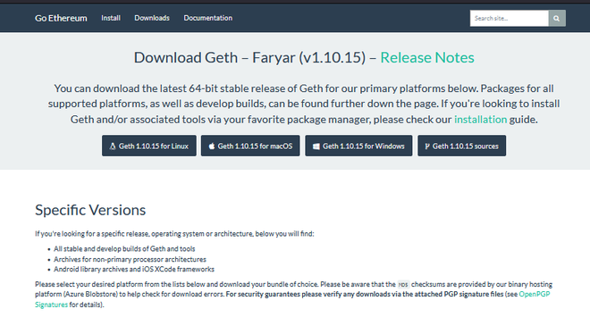

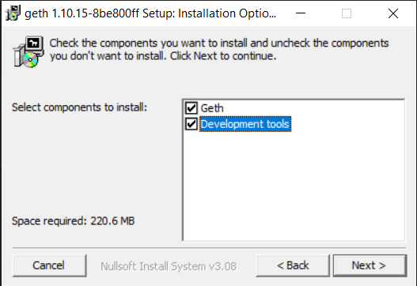

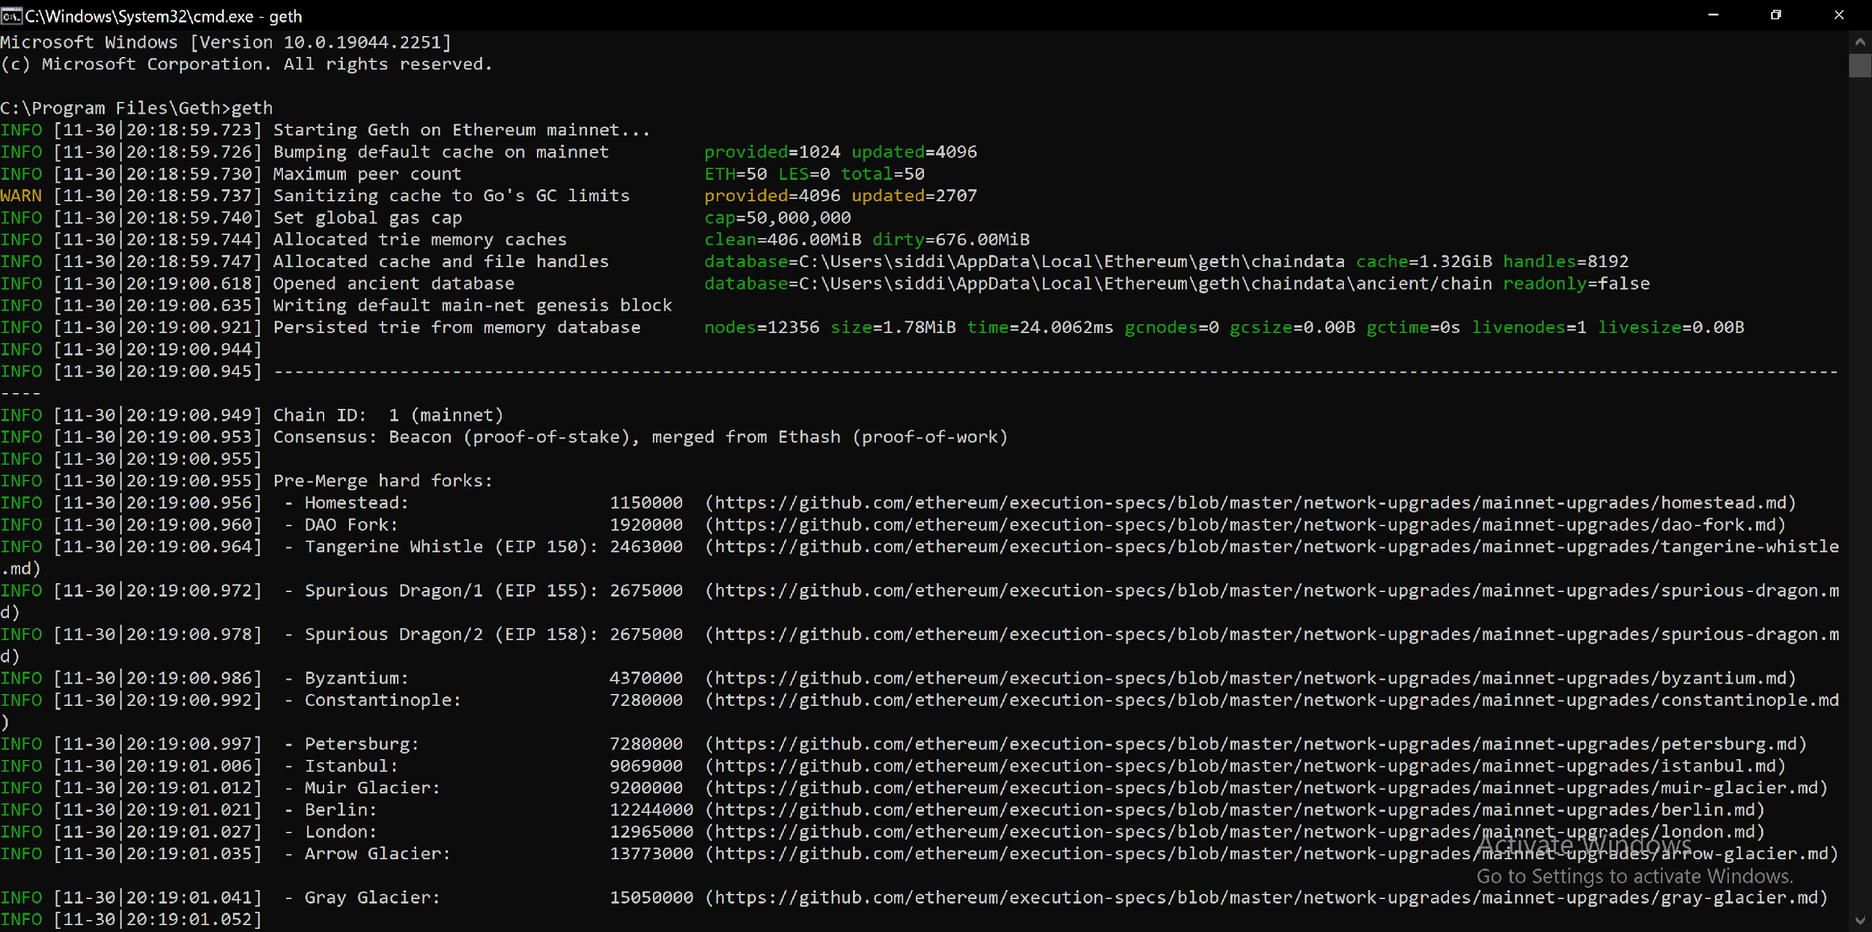

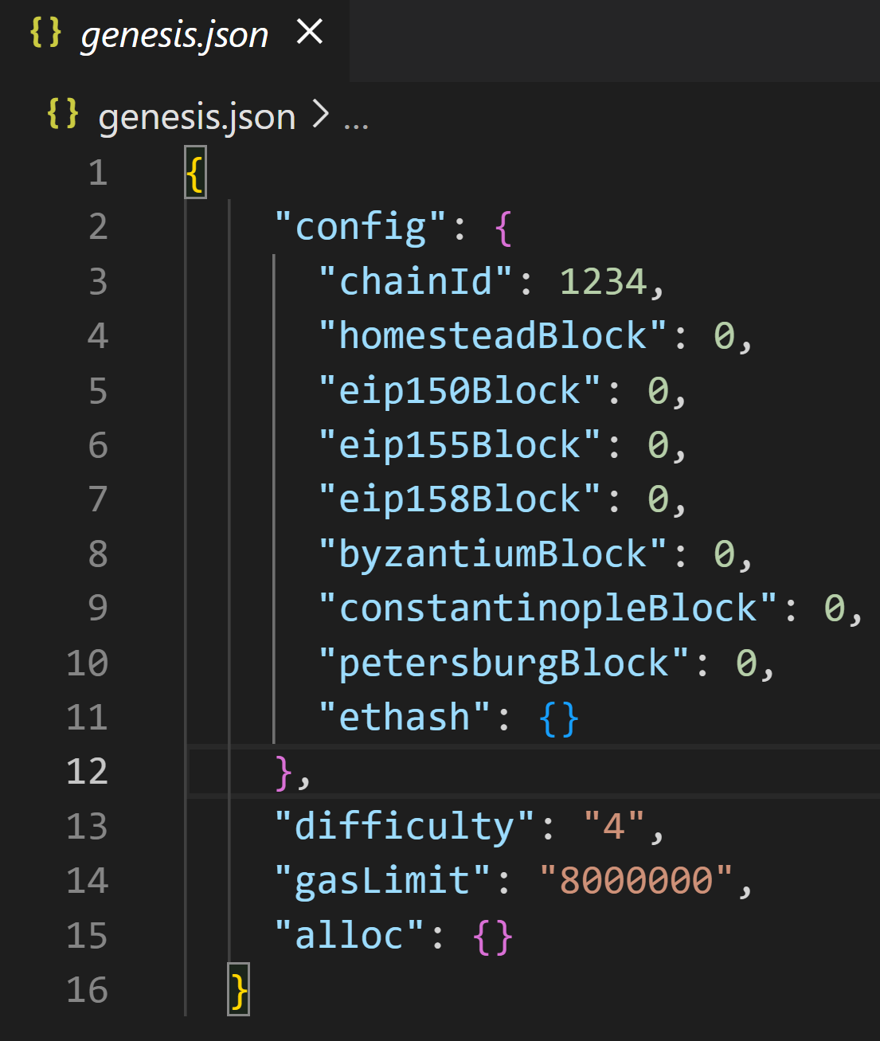

**Start Database:**

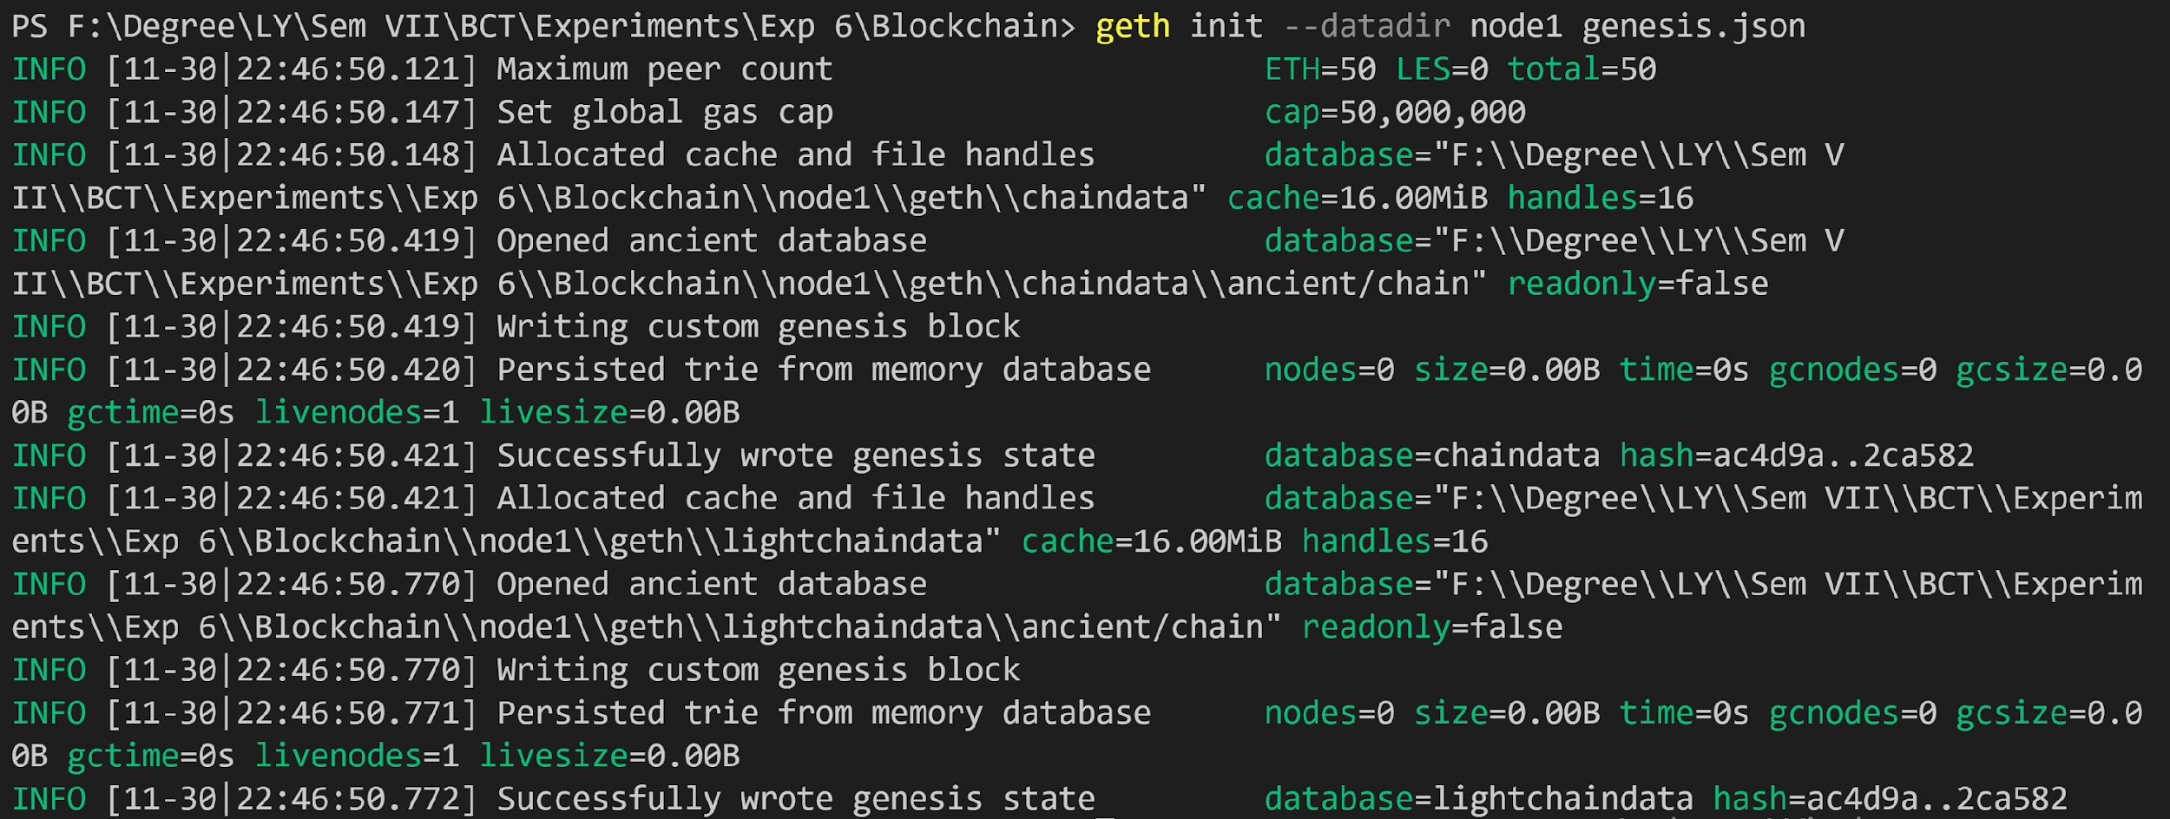

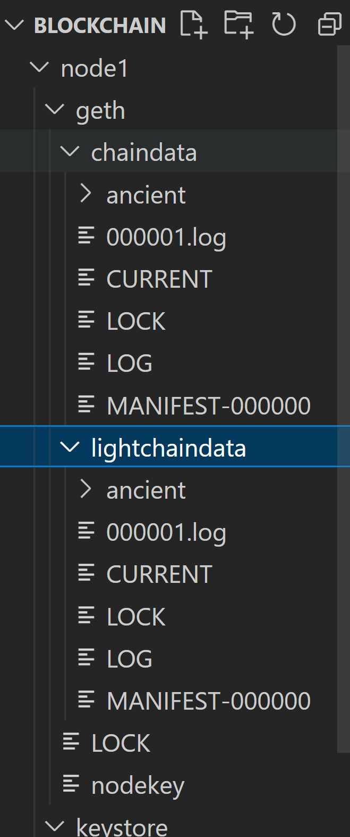

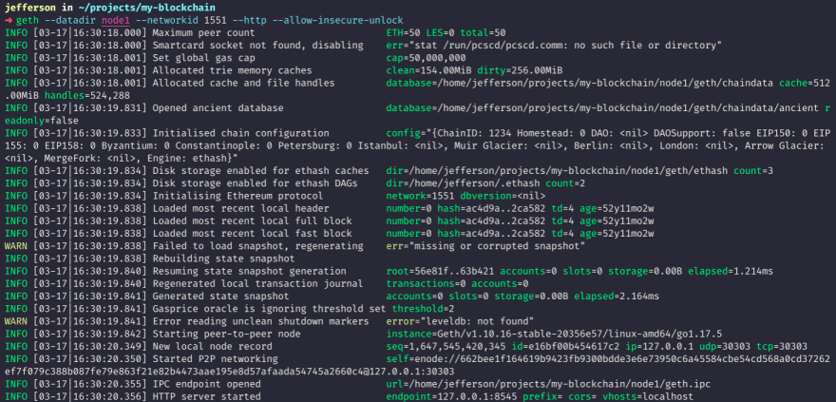

**Start Node**

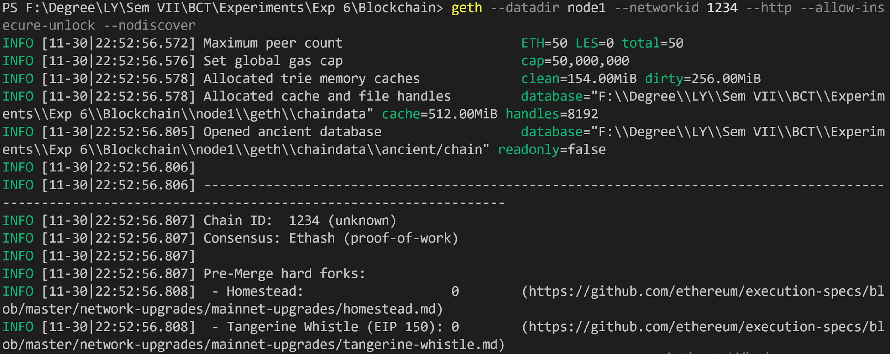

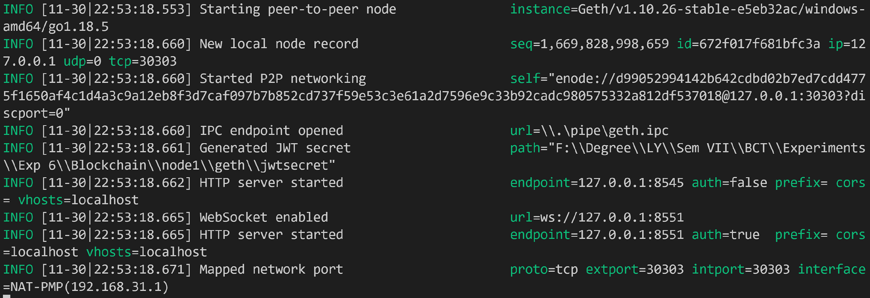

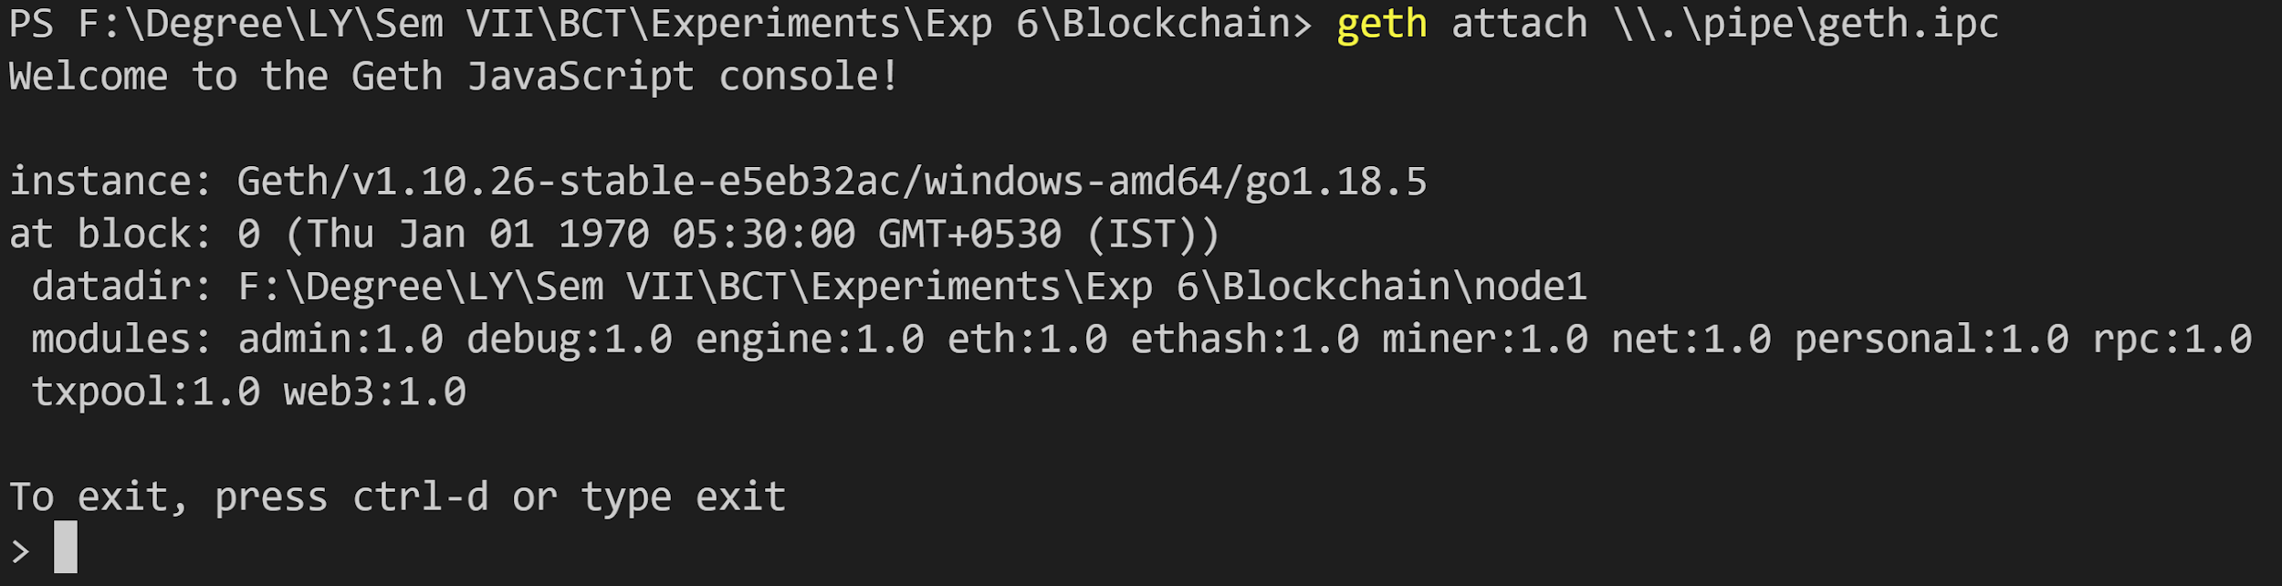

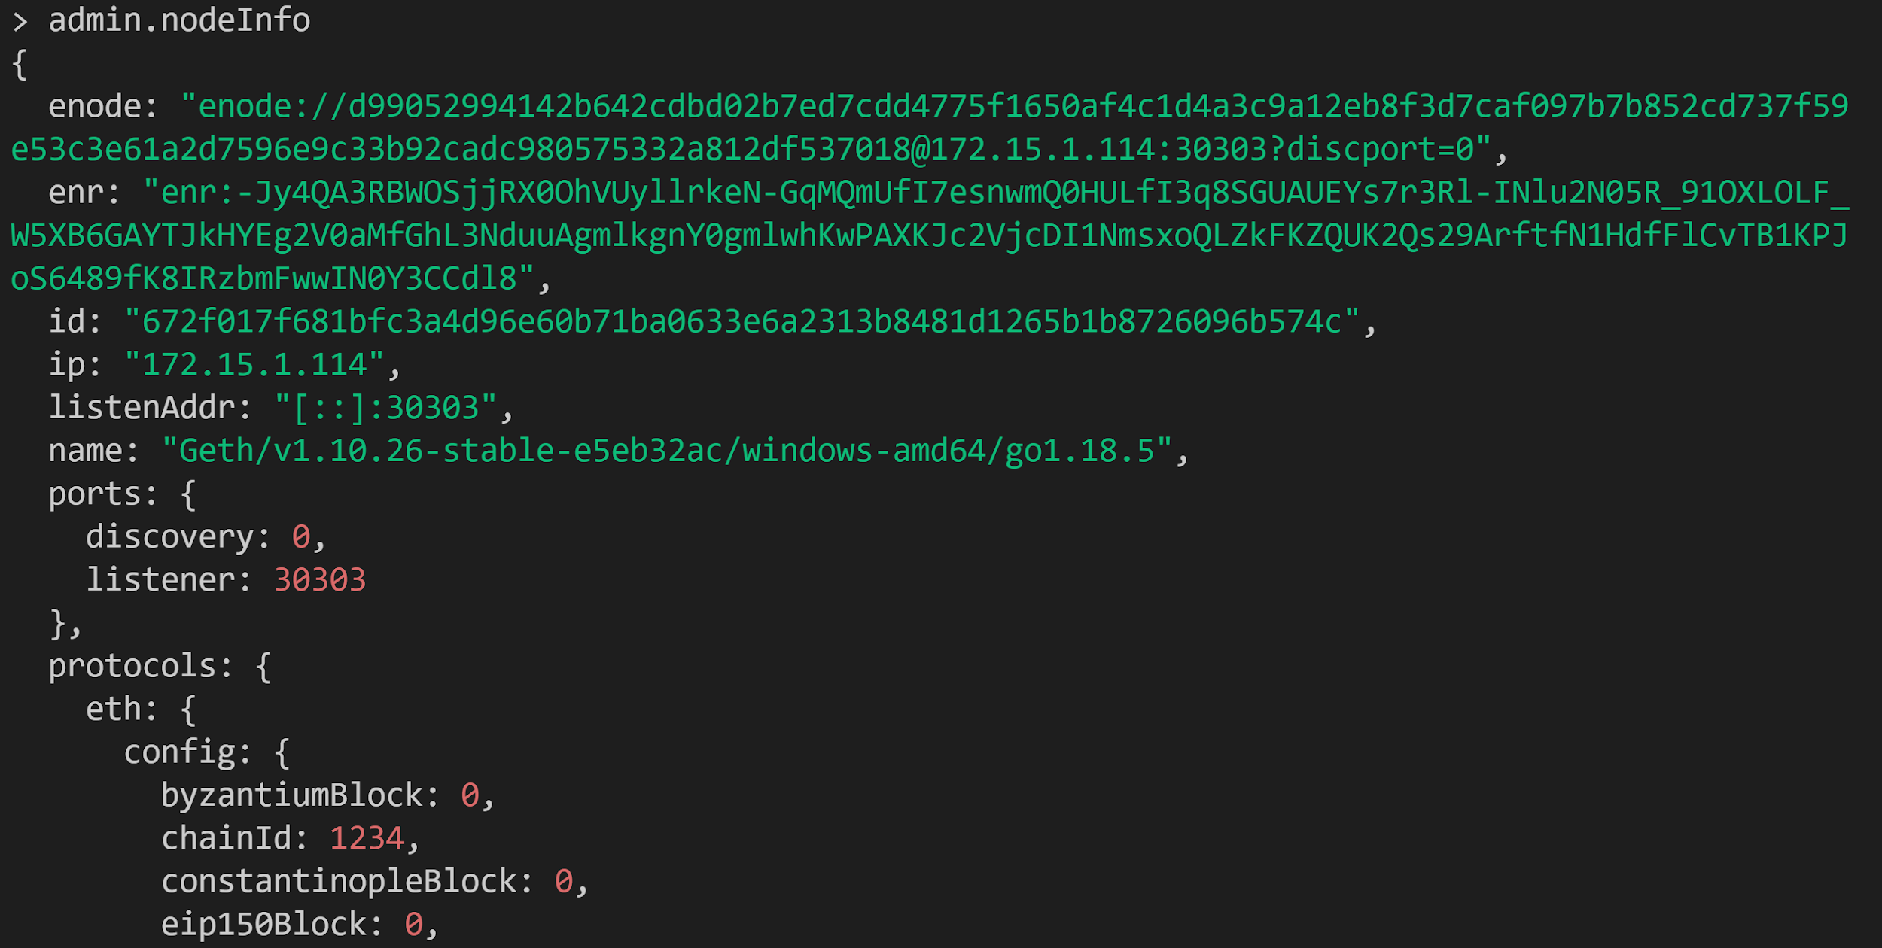

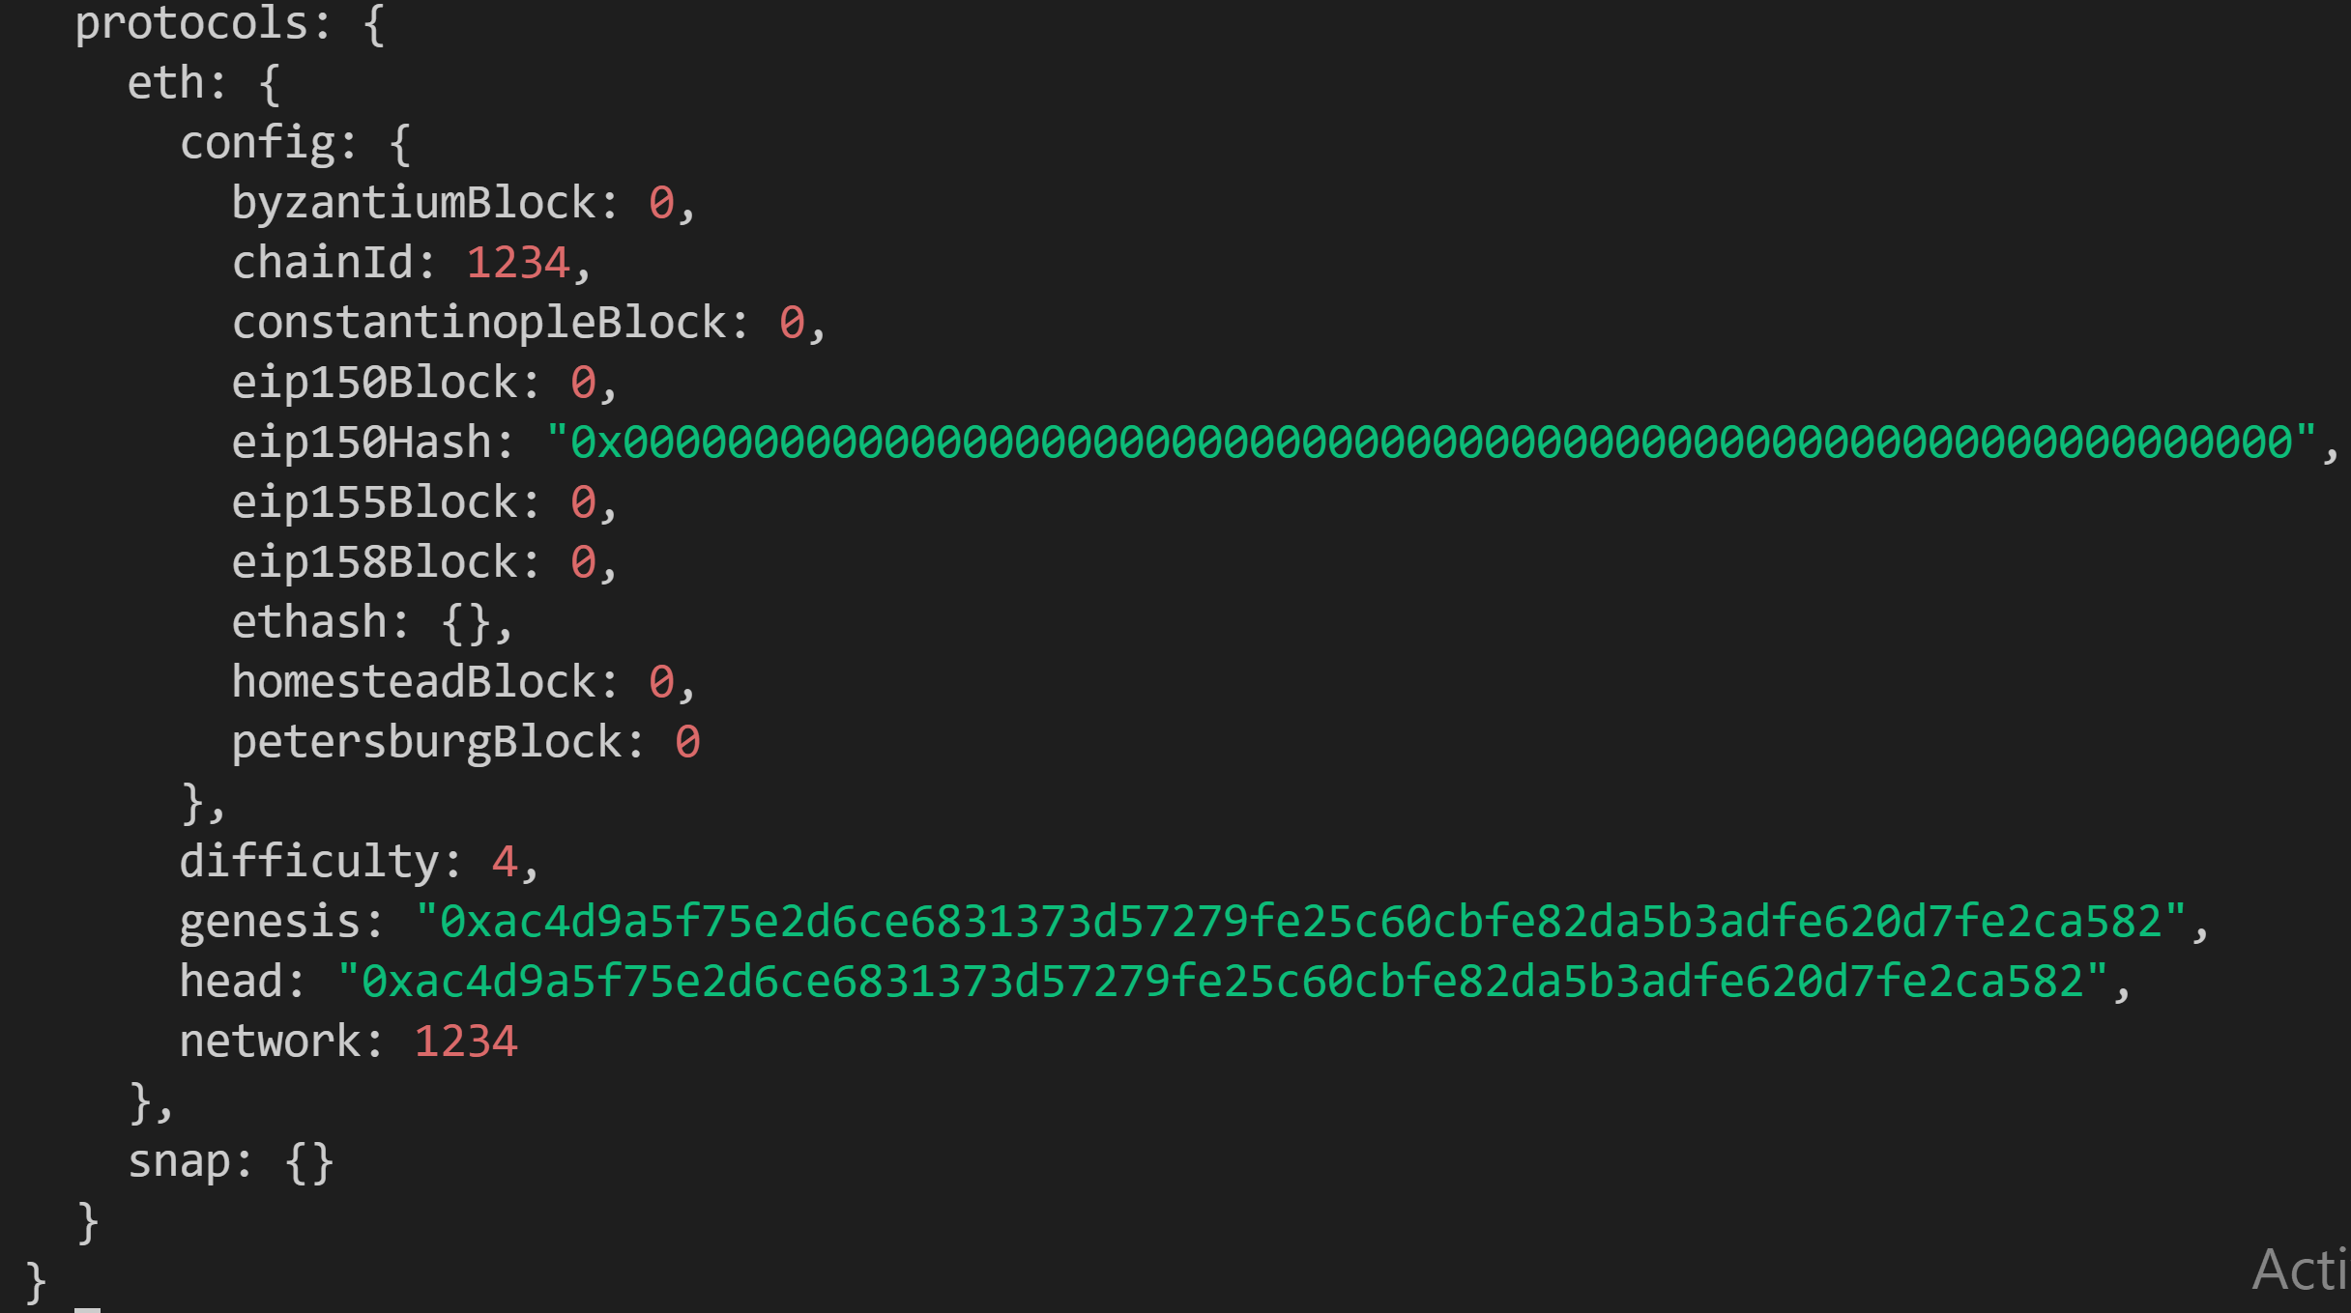

**Adding member peers:**

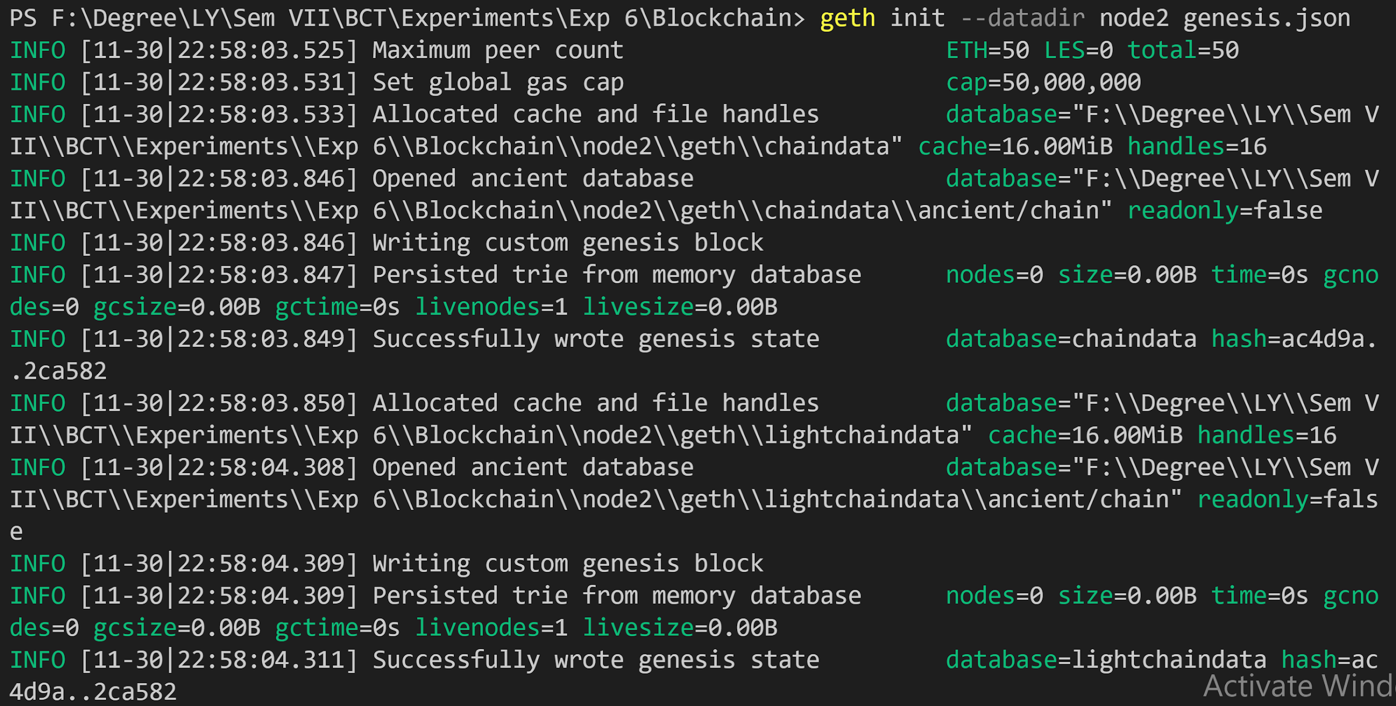

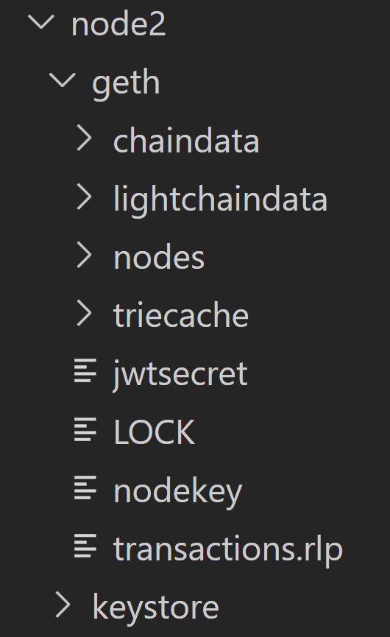

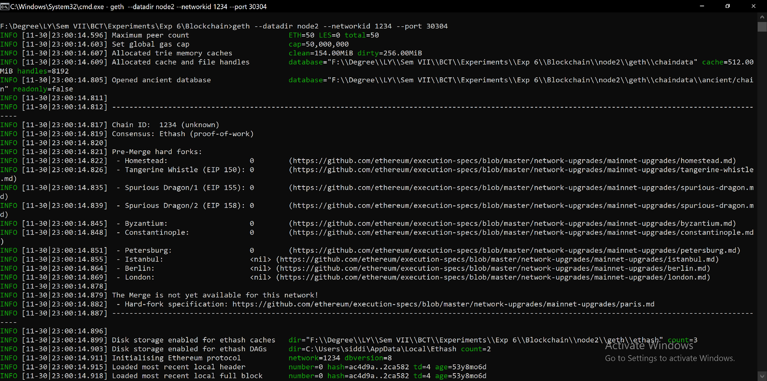

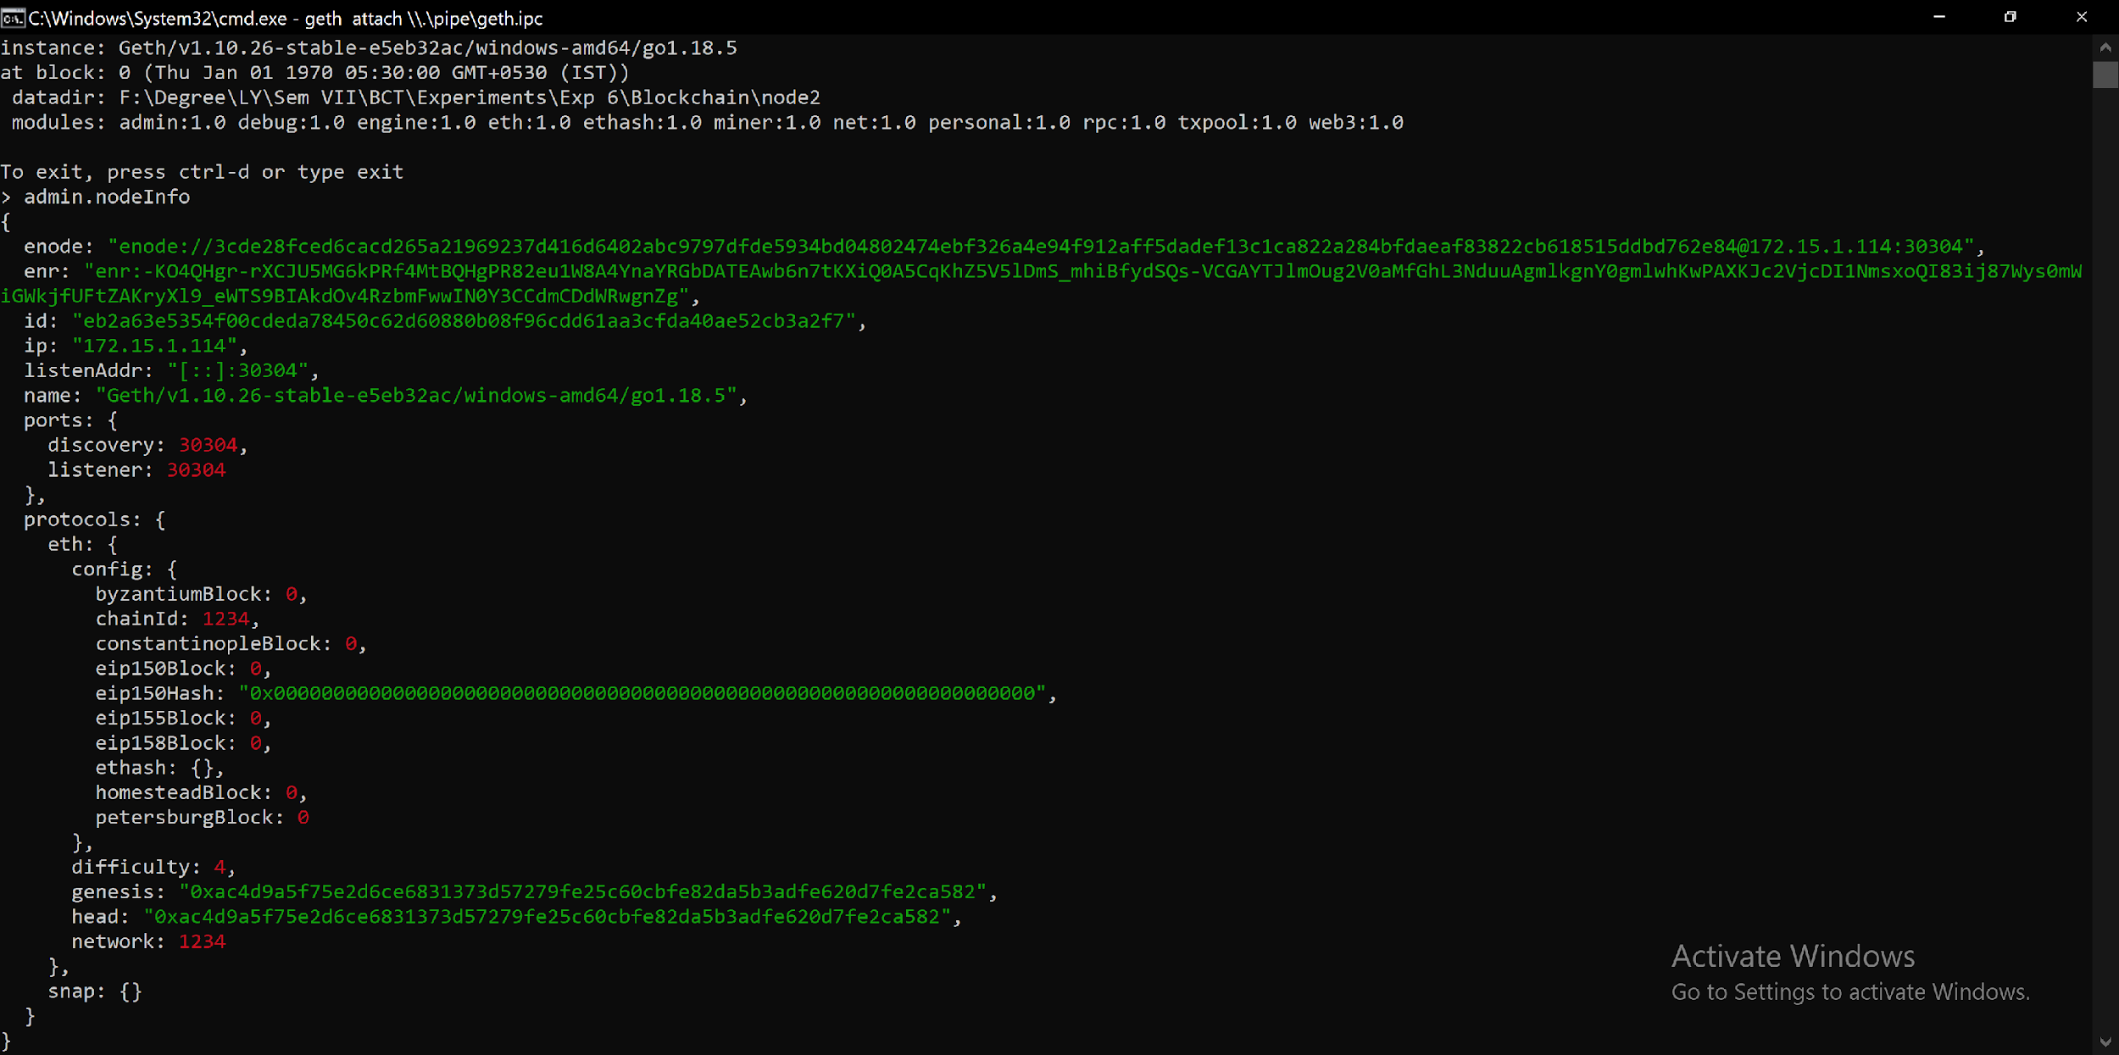

**Connecting Peers:**



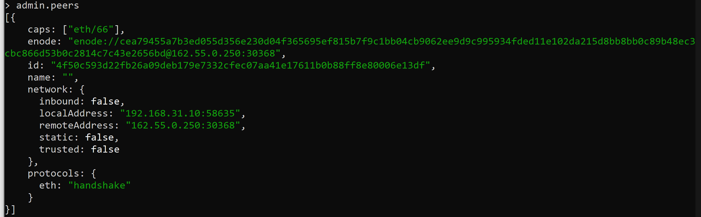

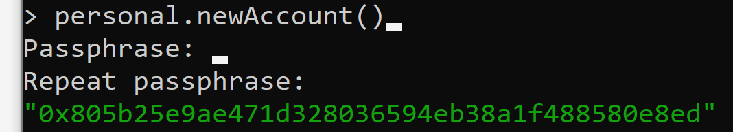

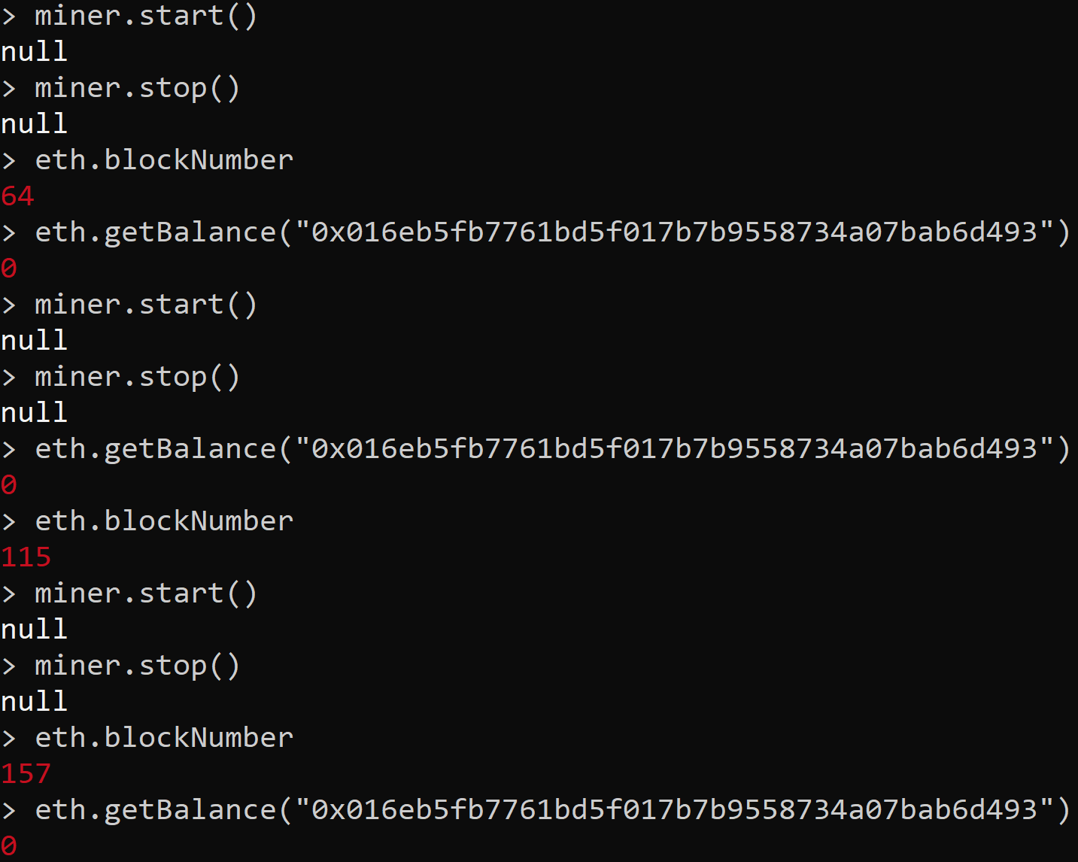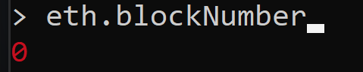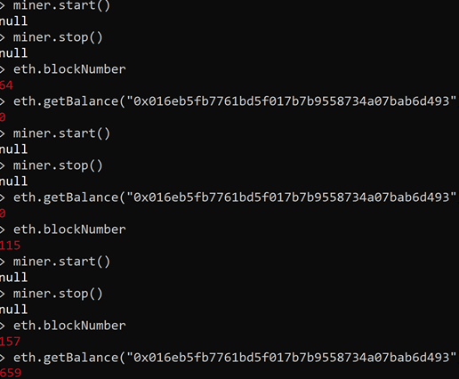

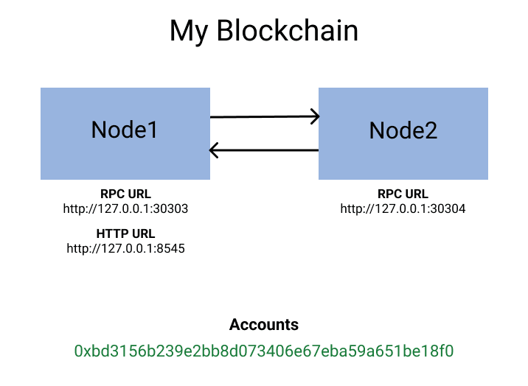

**Conclusion:**

Thus, we successfully understood and implemented the private Ethereum Blockchain using Geth.